Smart Public Restroom

# Importing the Dataset:

Identify and obtain a dataset related to smart public restrooms. This dataset might include sensor data, usage statistics, maintenance records, and environmental data.

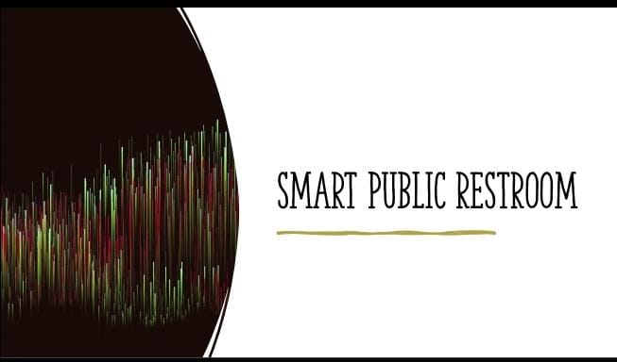

Ensure the dataset is in a suitable format for analysis, such as CSV, JSON, or a database.

Consider integrating real-time data streams from IoT sensors within the restrooms for ongoing analysi2. Data Cleaning:￼

1. **Data Cleaning:**

Prepare the dataset for analysis by addressing issues such as:

Handling missing or null values through imputation or removal.

Identifying and eliminating duplicate entries.

Standardizing data types and units of measurement for consistency.

Removing outliers that may skew the analysis.

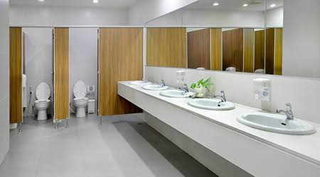

1. **Data Analysis on IoT Platform:**

Select an IoT platform that aligns with your project goals, such as AWS IoT, Azure IoT, or Google Cloud IoT, and set up the necessary infrastructure.
Ingest the cleaned dataset into the IoT platform's data storage component.
Leverage the IoT platform's analytics tools and services to conduct various analyses:
a. Usage Patterns Analysis: - Analyze restroom usage patterns over time to identify peak hours and trends. - Utilize sensor data to monitor occupancy and detect restroom congestion.
b. Maintenance Optimization: - Predict maintenance needs for restroom facilities and equipment based on historical data and IoT sensor readings. - Implement predictive maintenance strategies to minimize downtime.
c. Resource Efficiency: - Assess resource consumption (e.g., water, paper towels) and optimize usage based on data-driven insights. - Use IoT data to control resource distribution efficiently.
d. User Experience Enhancement: - Gather data on user feedback and preferences. - Utilize IoT data to improve restroom amenities and services.
e. Environmental Impact Assessment: - Measure and analyze environmental factors such as energy consumption and water usage. - Implement eco-friendly practices based on IoT data insights.

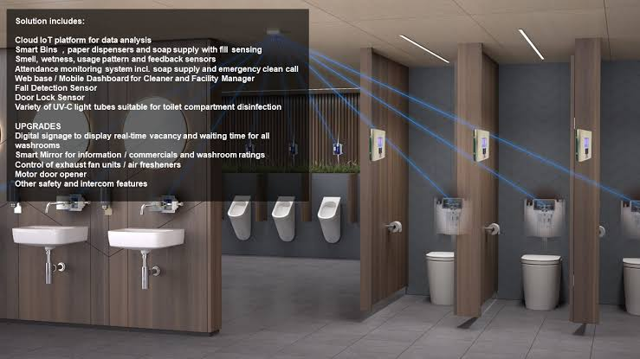

**4. Visualization and Reporting:**

Create visualizations, dashboards, and reports to communicate key findings and actionable insights to stakeholders.Ensure that the information is presented in an easily understandable format.

**5. Recommendations and Implementation:**

Provide recommendations based on your analysis to enhance the functionality and efficiency of smart public restrooms.

Collaborate with relevant authorities or facility management teams to implement these recommendations.

Remember that the success of a smart public restroom project also depends on user privacy, security measures for IoT data, and compliance with relevant regulations. These aspects should be considered throughout the SA process.

Free Research Preview. ChatGPT may produce inaccurate information about people, places, or facts. ChatGPT September 25 Version